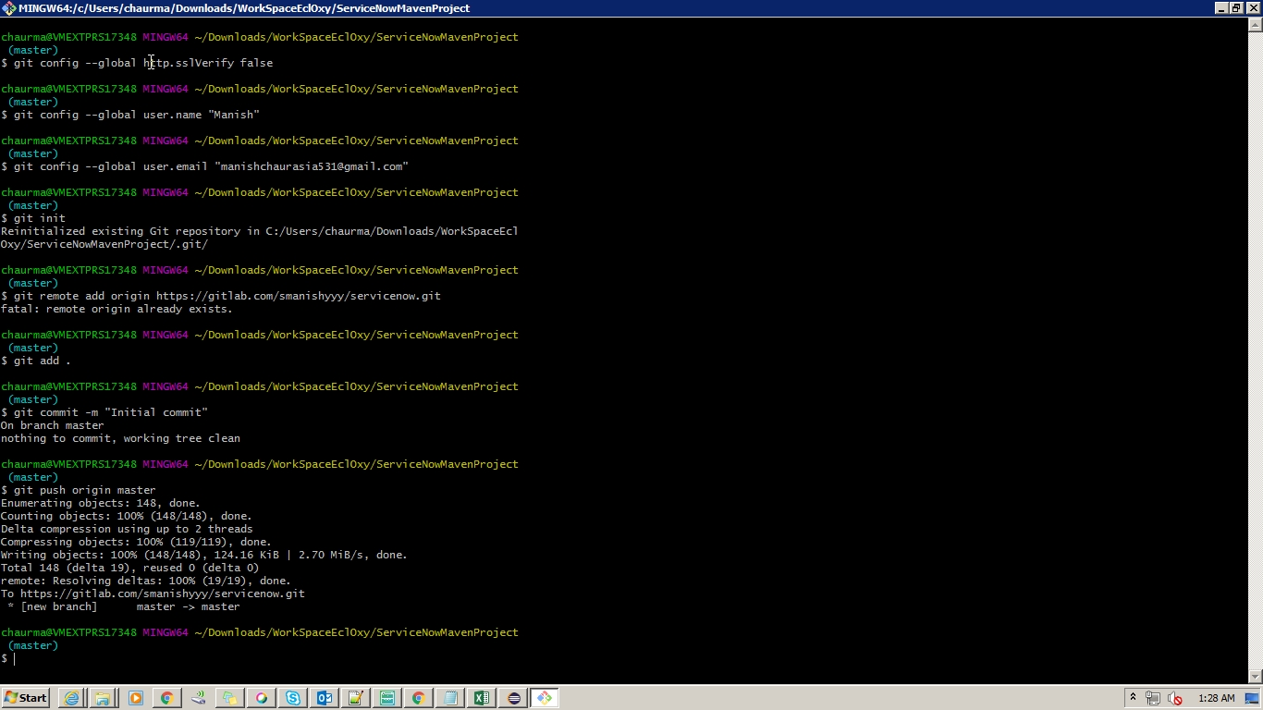Screenshot 1:4/3/2019 01:28:19.424